**INSTALLATIONS**

* Installing python version of 3.0 or above
* To install OpenCV, NumPy and matplotlib are to be installed.
* OpenCV installation
* Open python IDLE, Enter **import numpy**.
* Download latest OpenCV release from sourceforge site and double click to extract it.
* Goto OpenCV/build/python folder.
* Copy cv2.pyd to python/lib/site-packages.
* Checking OpenCV working or not
* Open python IDLE
* Enter **import cv2**
* If results are printed out without any errors, OpenCV Python is installed successfully.
* Open Python folder python/scripts
* Enter pip install tkinter **#** For selecting an image as input.

* **INSTALLATIONS FOR REAL TIME OBJECT DETECTION**
* Open Python folder python/scripts
* Enter pip install imutils **#** For video streaming
* Enter pip install argparse **#** For passing arguments
* **INSTALLATIONS FOR SHORTEST DISTANCE ON MAP**
* Open Python folder python/scripts
* Enter pip install geocoder **#** For decoding addresses to find latitude and longitude
* Enter pip install webbrowser **#** To display the shortest route on maps

**EXECUTION**

* Select PROJECT folder and open start.py shell program.
* Run the shell program by clicking F5 or run module from navigation bar.

Following GUI appears:

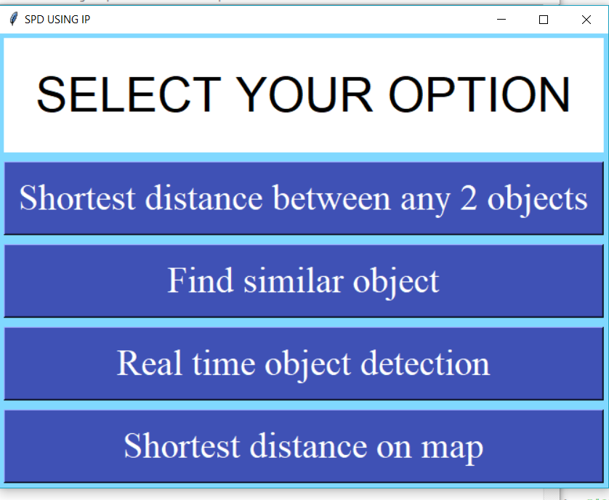

* Select an option from the GUI
* If **First option** is selected, then select an image from the folder
* All the objects in the image are displayed with their properties on the shell.
* Select any two objects from the displayed objects.
* The shortest distance between them is displayed on the shell.
* For **Second option** only single object is given, and it displays the resembled objects.
* When **Third option** is selectedcommand prompt appears.
* The following command **python real_time_object_detection.py --prototxt MobileNetSSD_deploy.prototxt.txt --model MobileNetSSD_deploy.caffemodel** is copied and pasted in command prompt where video stream starts and recognizes the objects.
* For **Fourth option** latitude and longitude of the source and destination are given as input and the shortest route from source to destination is displayed on the web browser.